Mandatory for the entire manuscript:
Font - "Times New Roman", font size - 10 p., alignment - "Justified", line spacing - "Single"

Type of article.
(Original article or Review article or Case Report or Short Communication) / Please review on the website of the magazine Journal of IMAB - 'Submission Preparation Checklist./

Title of the article should contain brief but informative content.
With Capital and lowercase letters, font "Times New Roman", font size 10 p., Alignment "Justified", line spacing "Single" for the entire Manuscript.

Name Surname¹, Name Surname², …,
1) Department ..., Faculty ..., Medical University, Institute or Health Facility, City and Country.
2) Department ..., Clinic or Ward, Faculty..., Institute or Health Facility, Medical University, City and Country.

Abstract:
Abstract text.
Abstract of no more than 250 words should contain the following major headings:
- Purpose,
- Material/Methods,
- Results,
- Conclusions.

Keywords: from 3 to 8 keywords or short phrases for indexing your article, separated by commas, should be placed under the abstract. Use terms from the Medical Subject Headings list from Index Medicus.

Introduction
Including aim and tasks; the introduction should state the background and purpose of the topic. Cite only those references which are strictly pertinent.

Article text. Article text. Article text. Article text. Article text. [1] References should be cited in the order of appearance in the text. The numbers of citations in the text should be given in square brackets [1]. Article text. Article text. Article text. Article text. Article text. Article text. [2]

Materials and Methods:
Giving enough information on the used approaches; the materials and methods or patients and methods section should describe materials or your subjects as well as the methods sufficiently in detail to allow other researchers to reproduce your study.

Describe statistical methods with enough detail to allow reproduction of the study by another researcher.

Results:
These should be given concisely; the use of tables and figures to illustrate the results is encouraged; the results which are presented in tabular or illustrative form should not be reiterated in the text, but only the most salient findings should be emphasized.
Article text. Article text. Article text. Article text. Article text. (fig. 1.)

Fig. 1. Headline or name of the image/graphics/figure
https://www.journal-imab-bg.org/en/instruction.htm
5/ Illustrative materials:
Figures, tables, diagrams, and drawings are submitted as separate files.
Their numbers, text, and legends are placed where they will appear in the manuscript's text.
- Figures are sent as PDF (preferably), TIFF, or JPG files with a resolution of at least 300 dpi, a minimum base length of a = 86 mm, numbered with Arabic numerals, and must be cited in the main text.
- Tables must be submitted in Excel or Microsoft Word format and must not have links to the main document or other archives containing a reasonable number of rows and columns. Do not format (merge cells) tables. The table title must be set on the same page as the table.
- Drawings should be in PDF (preferably), TIFF, or JPG files, numbered with Arabic numerals, and have a resolution of at least 300 dpi.
- Diagrams must be in Excel (preferred).

Article text. Article text. Article text. Article text. Article text. Article text. (table 1)

Table 1. Headline or the table
https://www.journal-imab-bg.org/en/instruction.htm
5/ Illustrative materials:
…
- Tables must be submitted in Excel or Microsoft Word format and must not have links to the main document or other archives containing a reasonable number of rows and columns. Do not format (merge cells) tables. The table title must be set on the same page as the table.

Discussion:
The presentation of results should be separate from a discussion of their significance; the section should not repeat results;

Conclusion/s/:
Logically arising from the actual results;

Abbreviations:
Only standard units of measurements and universal abbreviations are permitted; other abbreviations must by proceeded by full name at the first use. At the end of the text, an abbreviation list must be placed.

Acknowledgements:
Grants or funding of the research from pharmaceutical firms must be stated in the Acknowledgements. Authors may also acknowledge institutional funding or grants as well as technical assistance and contributions not justifying authorship.

References:
https://www.journal-imab-bg.org/en/instruction.htm
It is recommended that the number of references should not exceed 20 titles for the original articles and 40 titles for the reviews; at least 30 % of them should be published in the last 5 (five) years (2020-2024).
https://www.journal-imab-bg.org/files/Examples-Sample-Citation-and-Introduction-to-Citing-Journal-Articles.doc

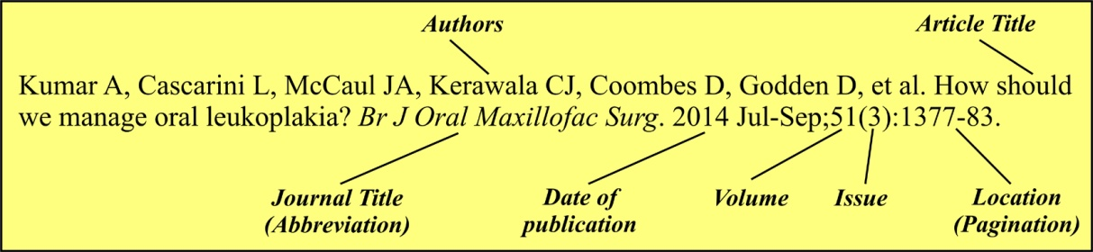
- List all authors when six or less; when seven or more, list only the first six and add "et al.". in Vancouver reference style.
- For the cited article, include real links to PubMed or Crossref when the article is deposited there.
1. Kostyanev T, Vilken T, Lammens C, Timbermont L, Van't Veen A, Goossens H. Detection and prevalence of carbapenem-resistant Gram-negative bacteria among European laboratories in the COMBACTE network: a COMBACTE LAB-Net survey. Int J Antimicrob Agents. 2019 Mar;53(3):268-274. [PubMed - https://pubmed.ncbi.nlm.nih.gov/30391381/ ]
2. Ng YL, Mann V, Gulabivala K. A prospective study of the factors affecting outcomes of nonsurgical root canal treatment: part 1: periapical health. IntEndod J. 2011 Jul;44(7):583-609. [PubMed - https://www.ncbi.nlm.nih.gov/pubmed/21366626]
3. Atanasov D. (Editor). [Oral surgery.] [in Bulgarian] Tafprint, Plovdiv, 2011: 255-259.
4. Luzzi S, Elia A, Del Maestro M, Morotti A, Elbabaa SK, Cavallini A, et al. Indication, Timing, and Surgical Treatment of Spontaneous Intracerebral Hemorrhage: Systematic Review and Proposal of a Management Algorithm. World Neurosurg. 2019 Apr;124:e769-e778. [PubMed - https://www.ncbi.nlm.nih.gov/pubmed/30677572]
5. Titianova E, Velcheva I, Andonova S. Stroke in Bulgaria: Recent Problems. Neurosonology and Cerebral Hemodynamics. 2015 May;11(1):7-13. [Internet - https://neurosonology.net/en/article/QinGNcZZZJ7uAlm0Cpgr ]
6. Vasilev P, Popovska S, Karaivanov M, Dimitrov D, Yordanova I. Squamous cell carcinoma of the skin: a study of clinicohistopathological correlations predictive for recurrence, metastasis and mortality. J of IMAB. 2023 Oct-Dec;29(4):5139-5144. [Crossref - https://doi.org/10.5272/jimab.2023294.5139 ]

Address for correspondence:
Name of leading author,
Institution and address of the leading author for correspondence and feedback
Address:
E-mail: . . . . @ . . .

Each of the authors has provided his ORCID ID ( https://orcid.org/ ) as follows:
Name and Surname in ORCID IDs - http://orcid.org/0000-000?-????-????

